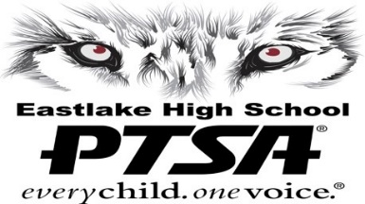
Eastlake High School PTSA 2.8.88

Mission Statement
Inspire unity. Exceed standards. Achieve success for all students.
2024-2025 Values & Goals
Approved

EXCELLENCE
Uphold PTSA Best Practices and Standards of Excellence to achieve success for the Eastlake community.
• Achieve at least the Gold level of WSPTSA Standards of Excellence
• Recognize student excellence through programs such as quarterly Recognition Receptions
• Recognize excellence in volunteers and staff through programs such as State PTSA Awards and Staff Appreciation

COMMUNICATION
Promote communication among the community; ensure that ideas and opinions are heard and valued.
• Weekly Wolf Tracks, Facebook, Instagram, Twitter and Website updates
• Communicate pertinent information with Community Liaison, EHS Senate, and Middle Schools
• Promote EHS PTSA contributions, collect feedback through surveys and open communication
• Evaluate process to move toward a paperless PTSA

EDUCATION SUPPORT
Support and enhance the comprehensive education of all students through grants, scholarships and activities.
• Build funding to intentionally provide grants to benefit maximum students
• Fund scholarships and other needs fairly and objectively
• Provide direct educational support through programs such as Test Prep, Math Lab, Reflections

ADVOCACY
Advocate for all students, staff and families through local, state and national PTA.
• Strive for 100% membership of parents and staff
• Attend council meetings regularly
• Active involvement in legislative activities and communication with membership regarding pertinent issues

PARTICIPATION
Encourage Eastlake community participation by supporting programs, events, and other needs.
• Build “as needed” volunteer participation
• Promote school identity through programs such as Apparel and Wall Tiles
• Build community through programs and services such as Holiday Bazaar, Parent Education, Convocation, Community Service and other events.

WELL-BEING
Assist in ensuring health, safety and well-being; promote a safe and harmonious environment where all are respected.
• Represent special needs, including Pantry Packs and Angel Fund programs
• Assist in health and safety programs such as Emergency Prep and the Prevention Interventionist Counselor
• Promote safety through the Parent Pledge, Senior Sendoff, and other events

